# Tutorial on Adding SEM Sensors Based on MQTT in Home Assistant

**First，turn on the switch in the Home Assistant app.**

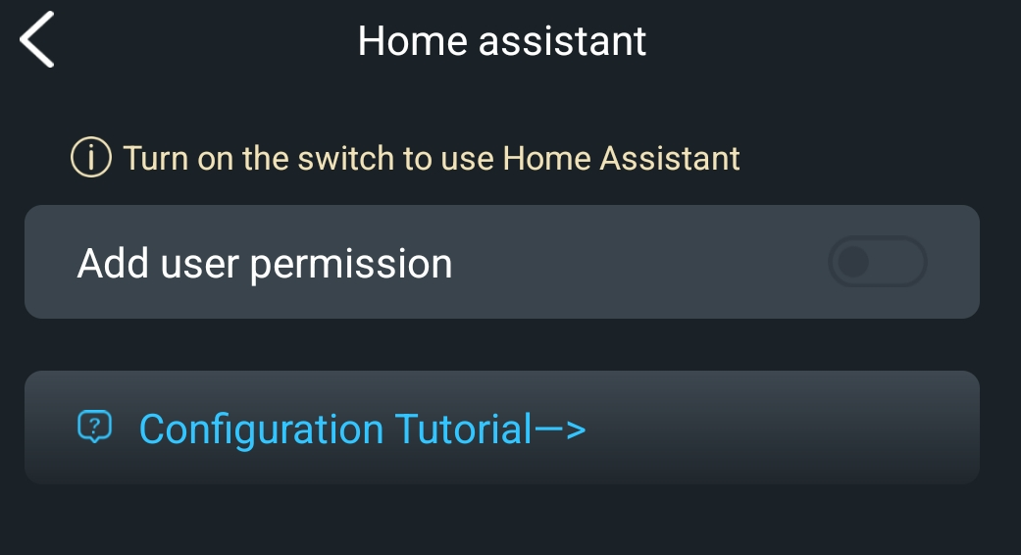

**Connect and configure MQTT**

Setting--> Devices & Services --> Integrations --> Add Integration --> Search for MQTT --> Click to configure information such as domain names and ports.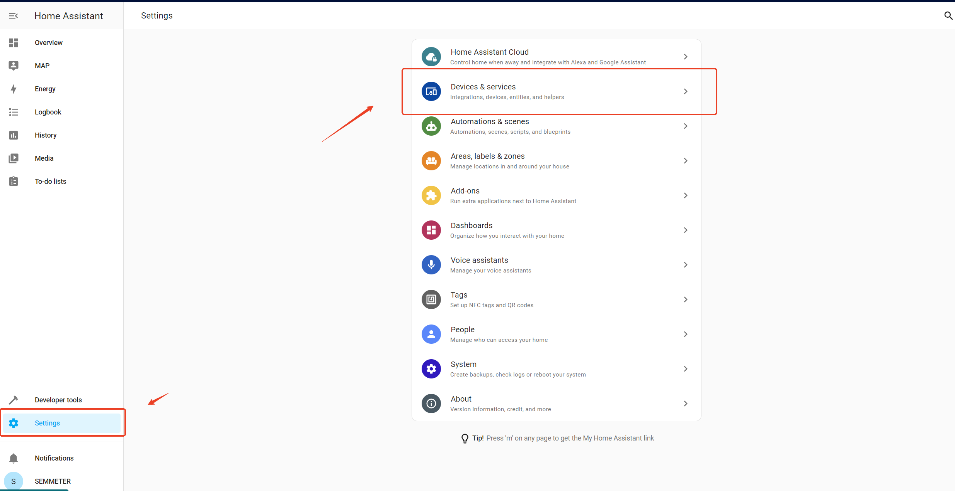  
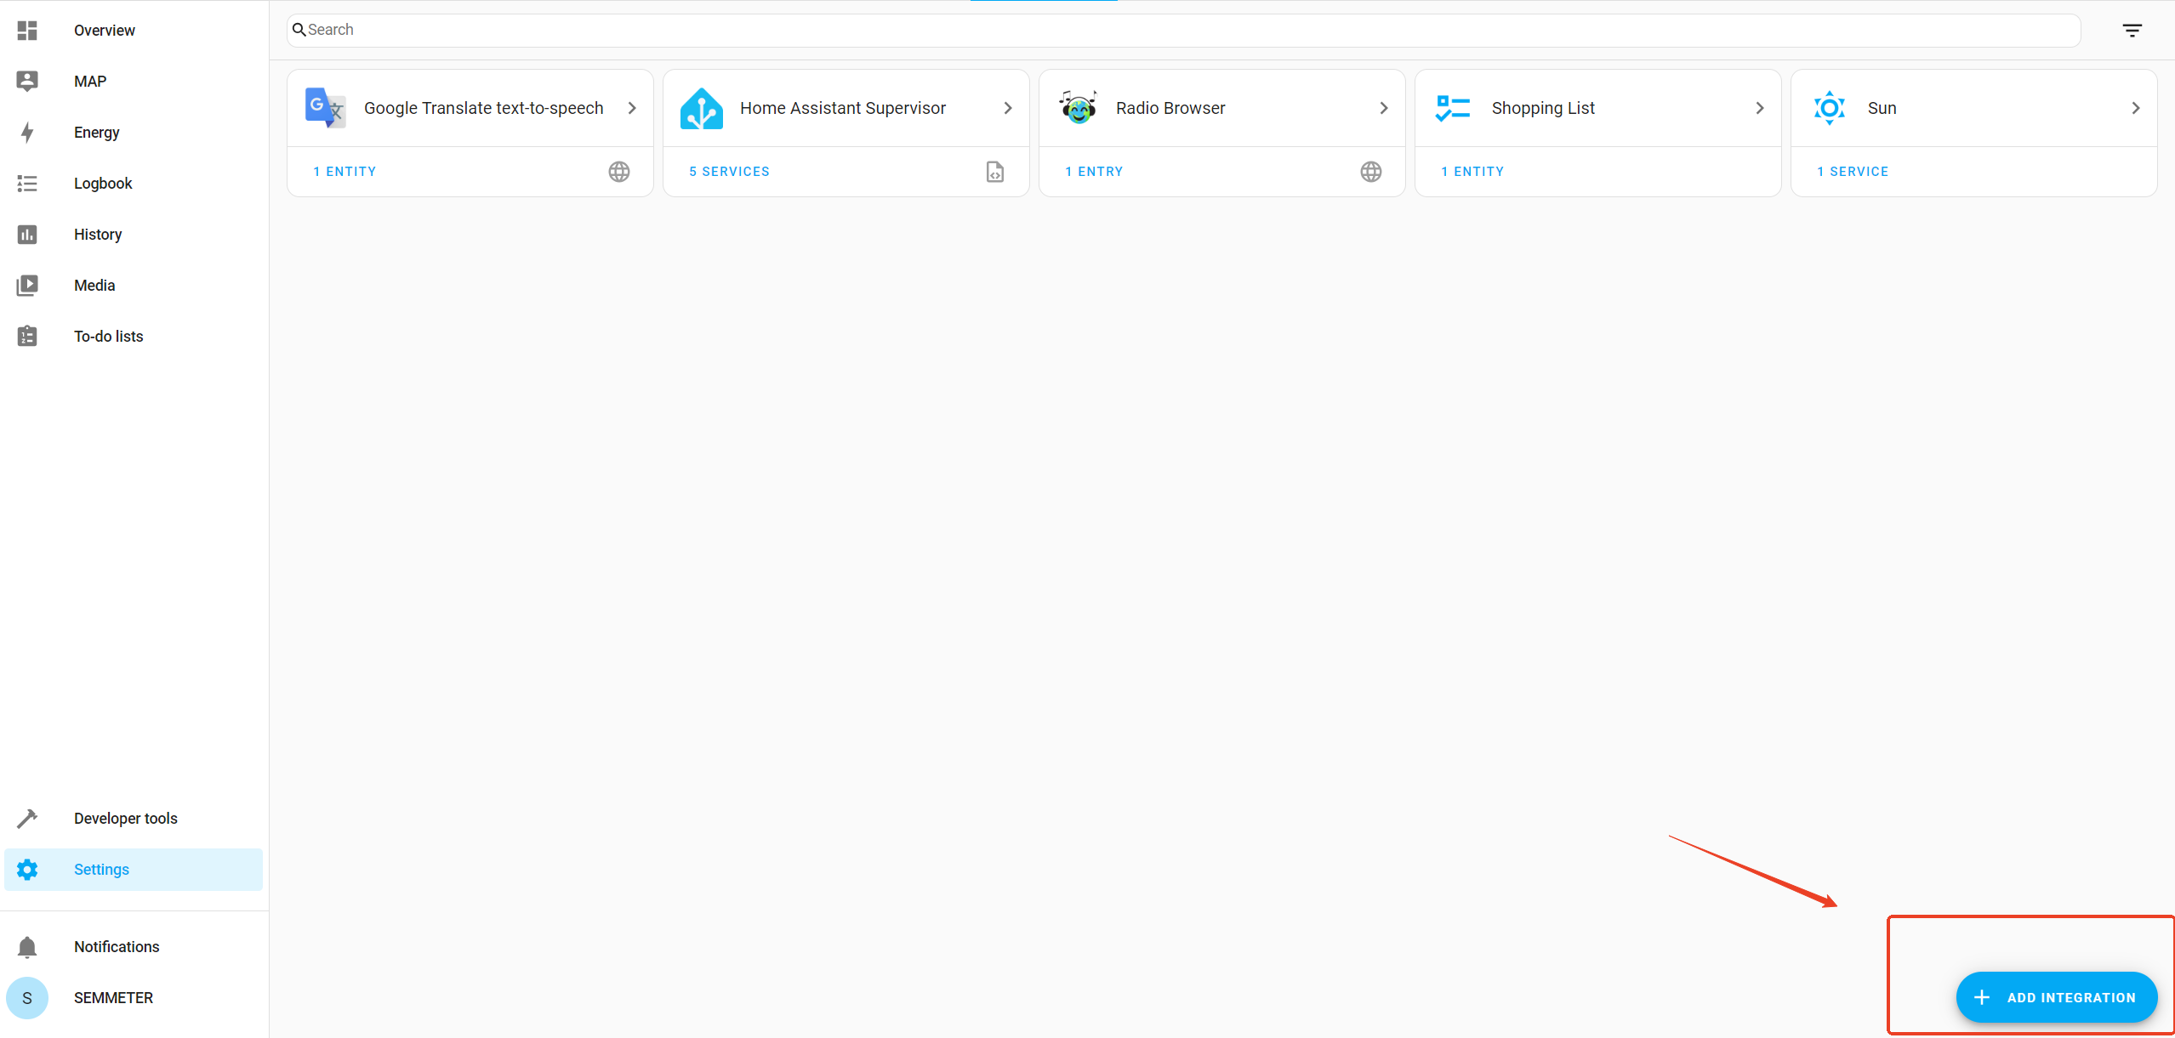  
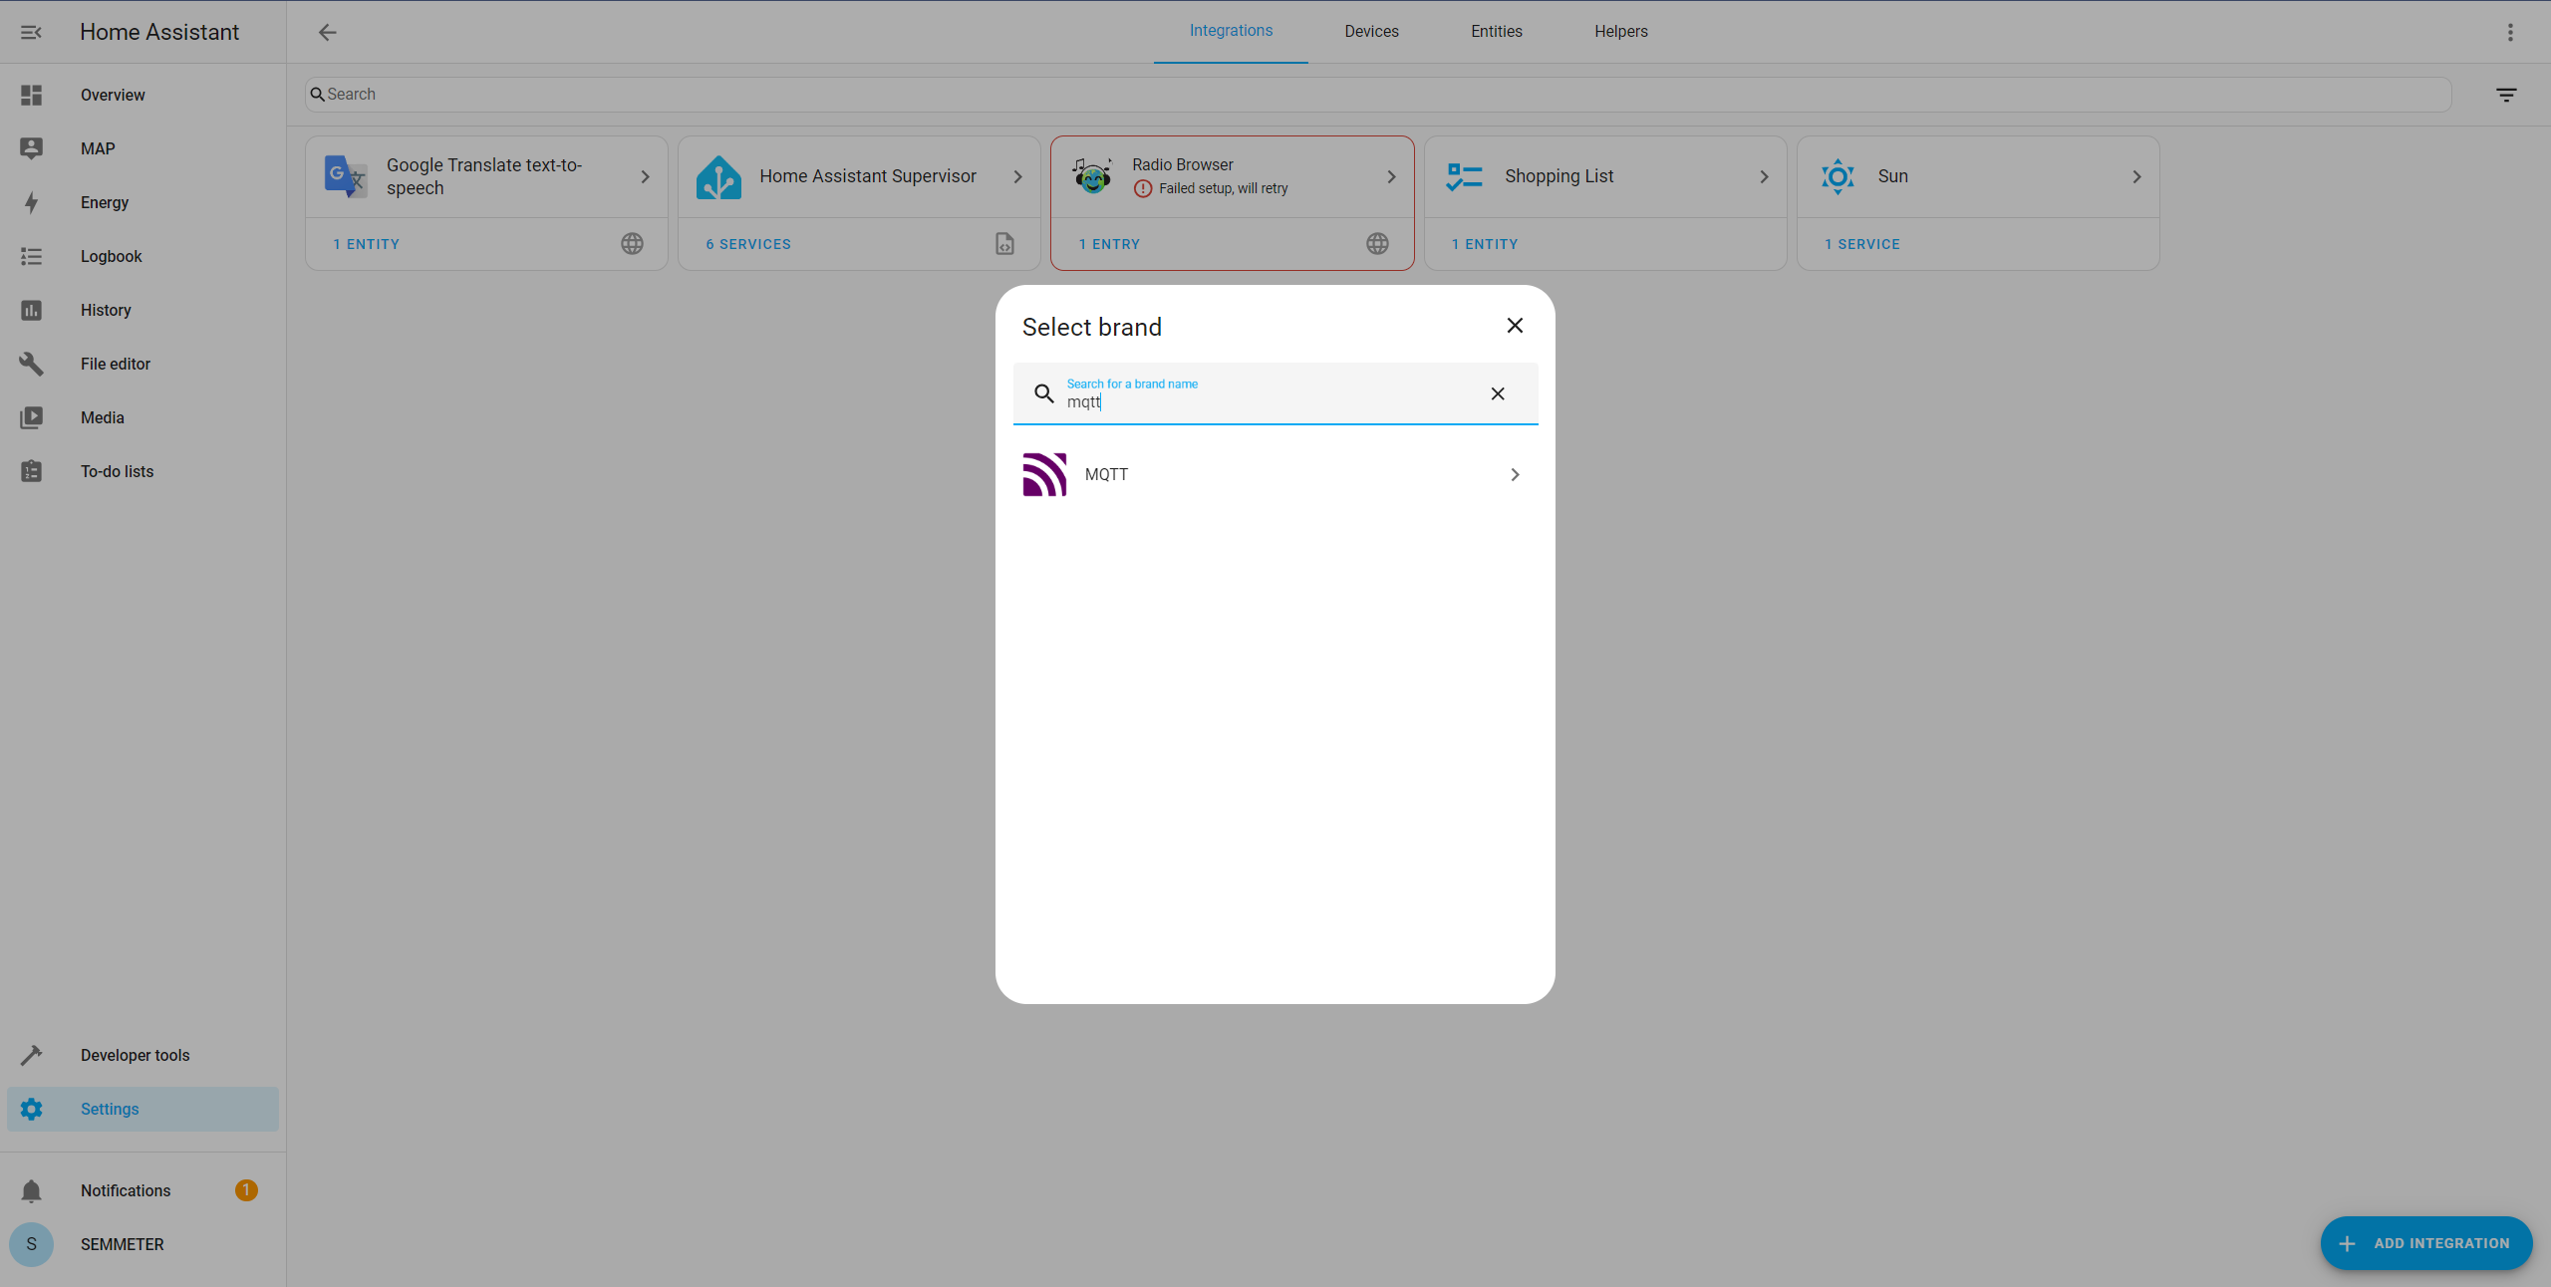

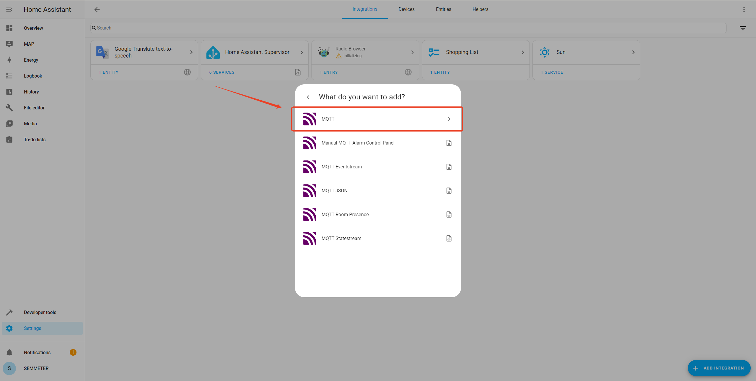

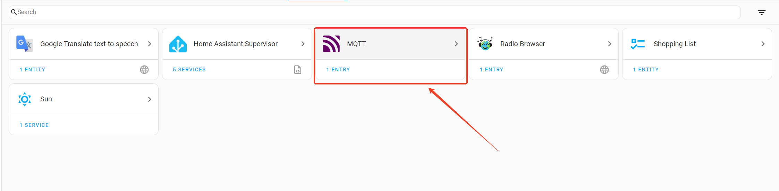

mqtt broker: mqtt001.tumblevd.com

Port: 6000

Username: your email

Password: your password(If it's a quick login via Apple or Google and no password has been set, the default password is "semmeter"）

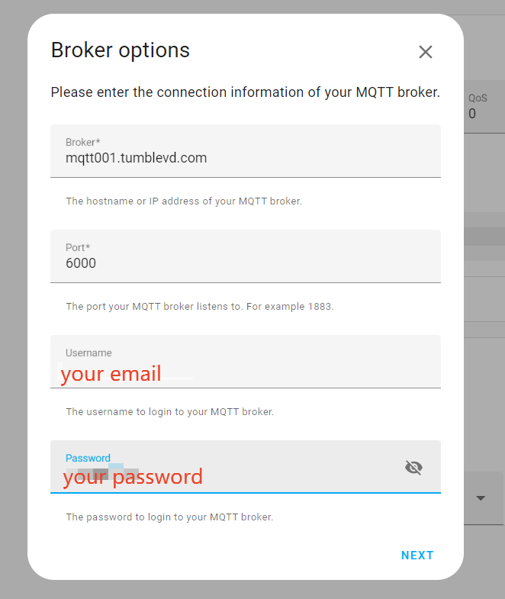

**Modify the configuration.yaml**

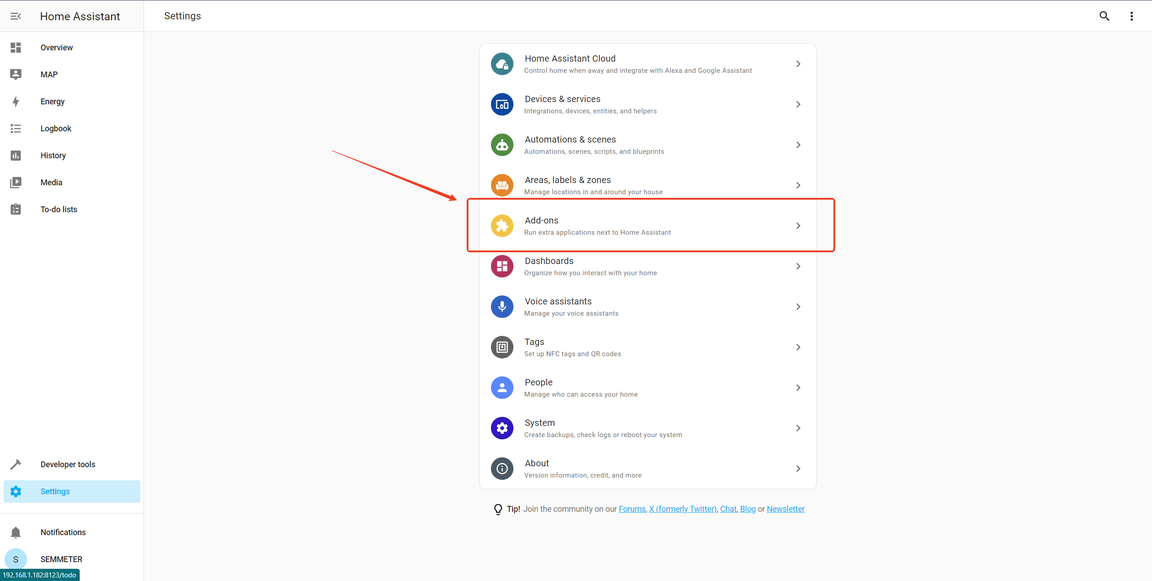

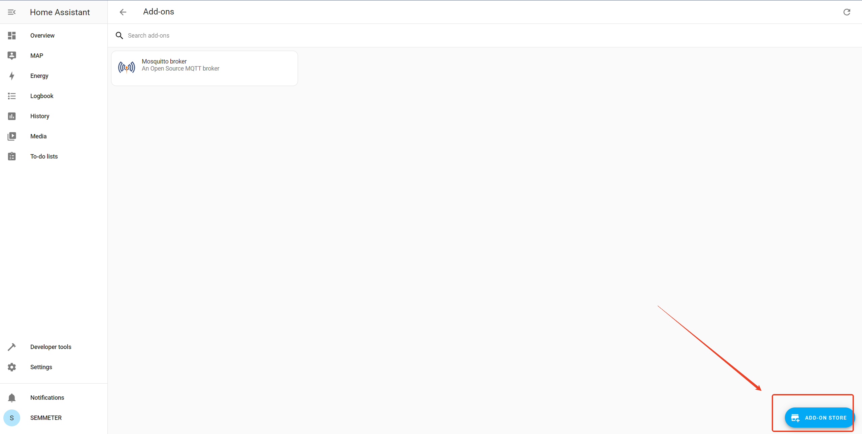

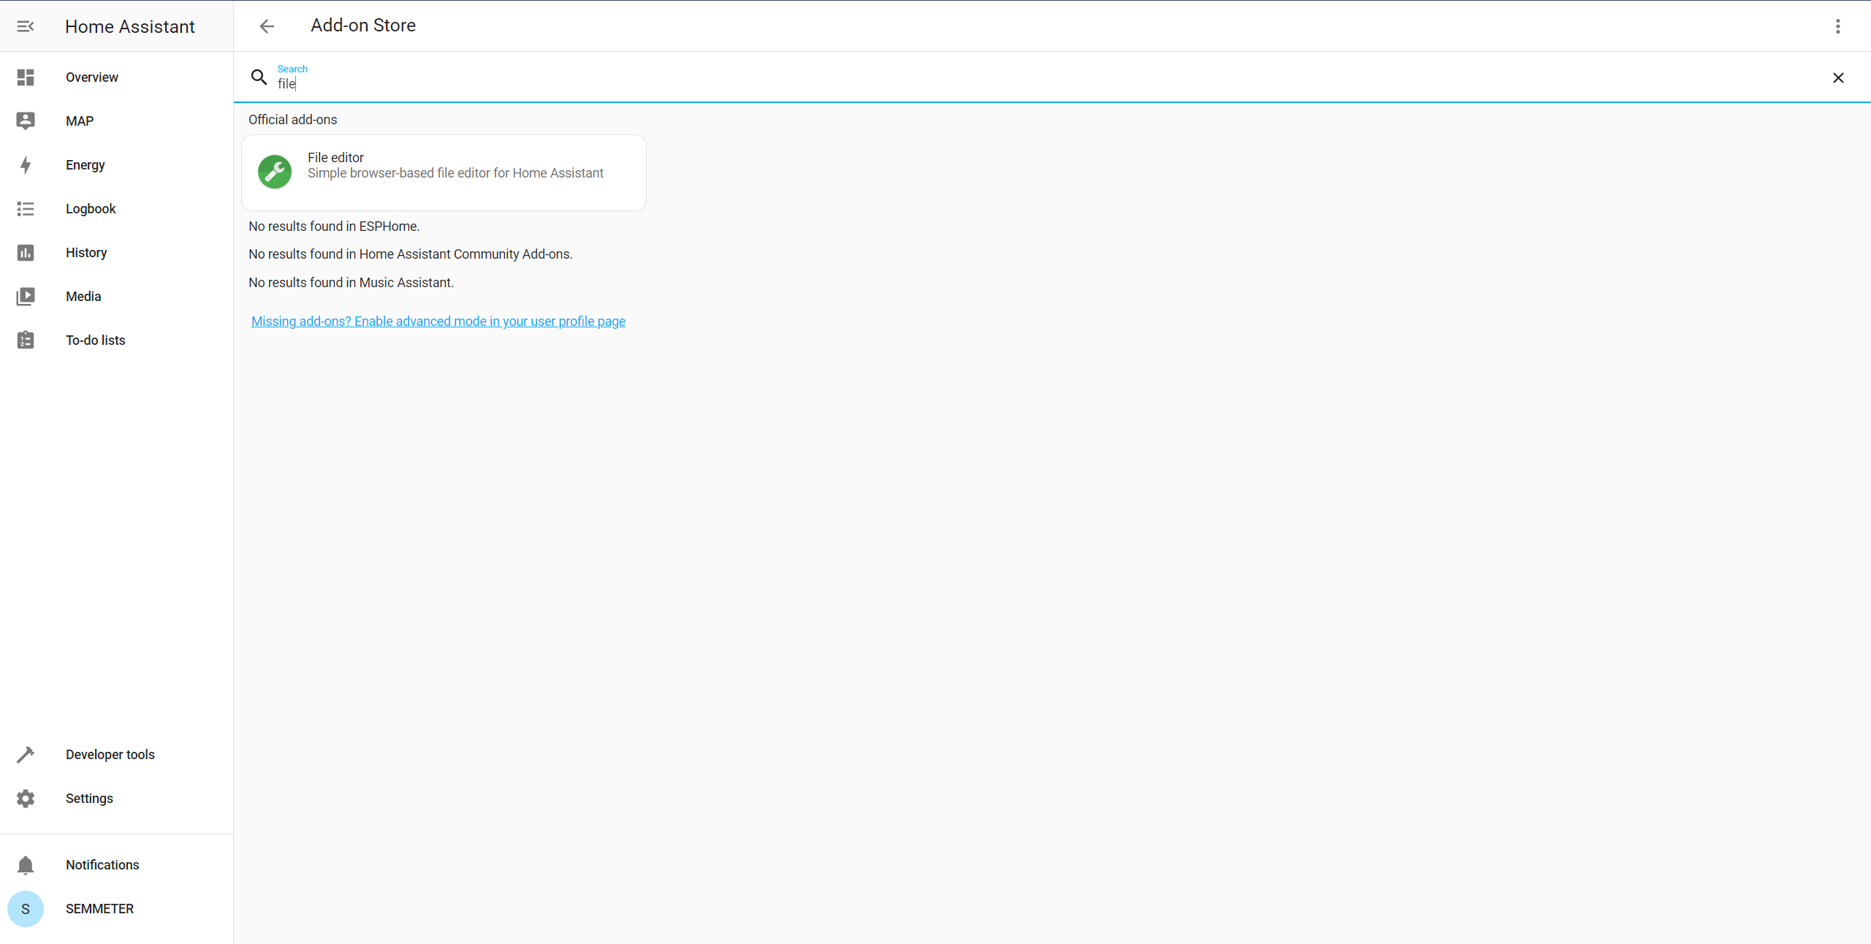

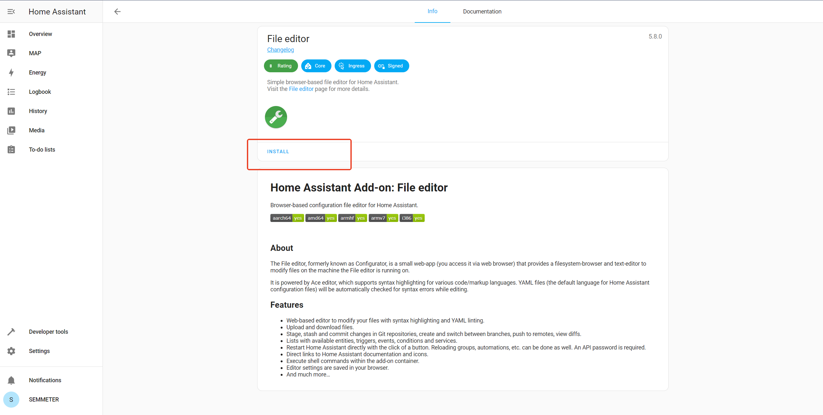

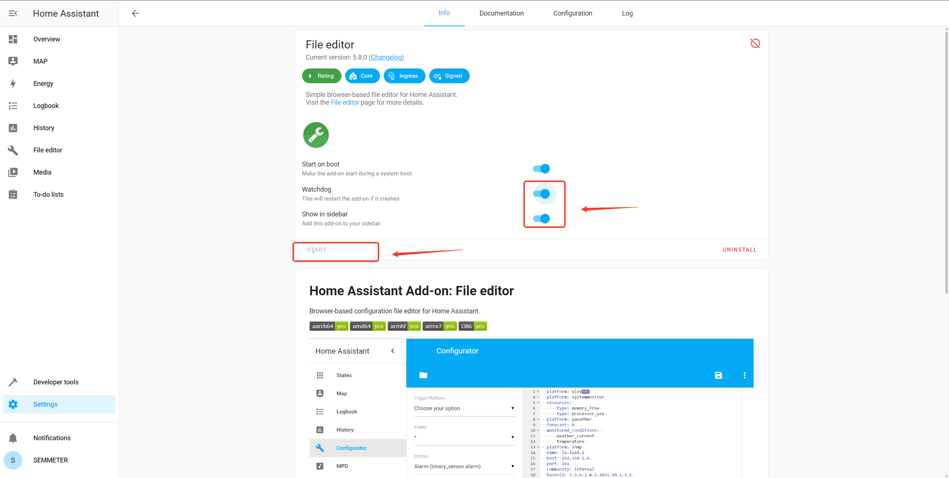

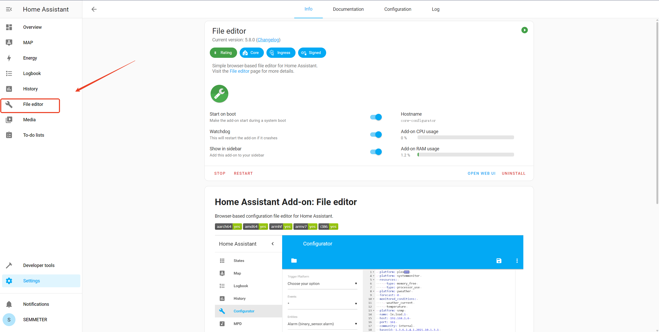

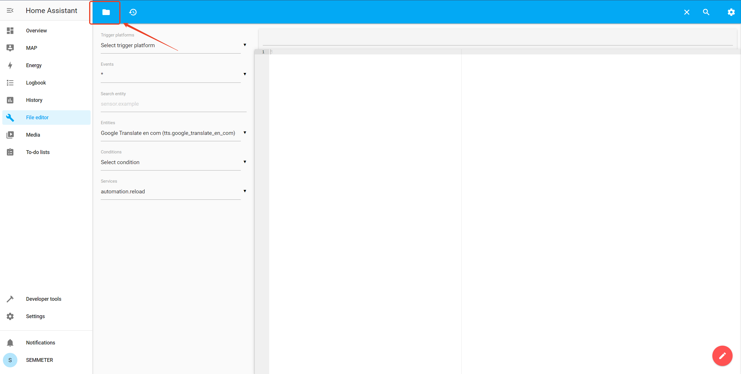

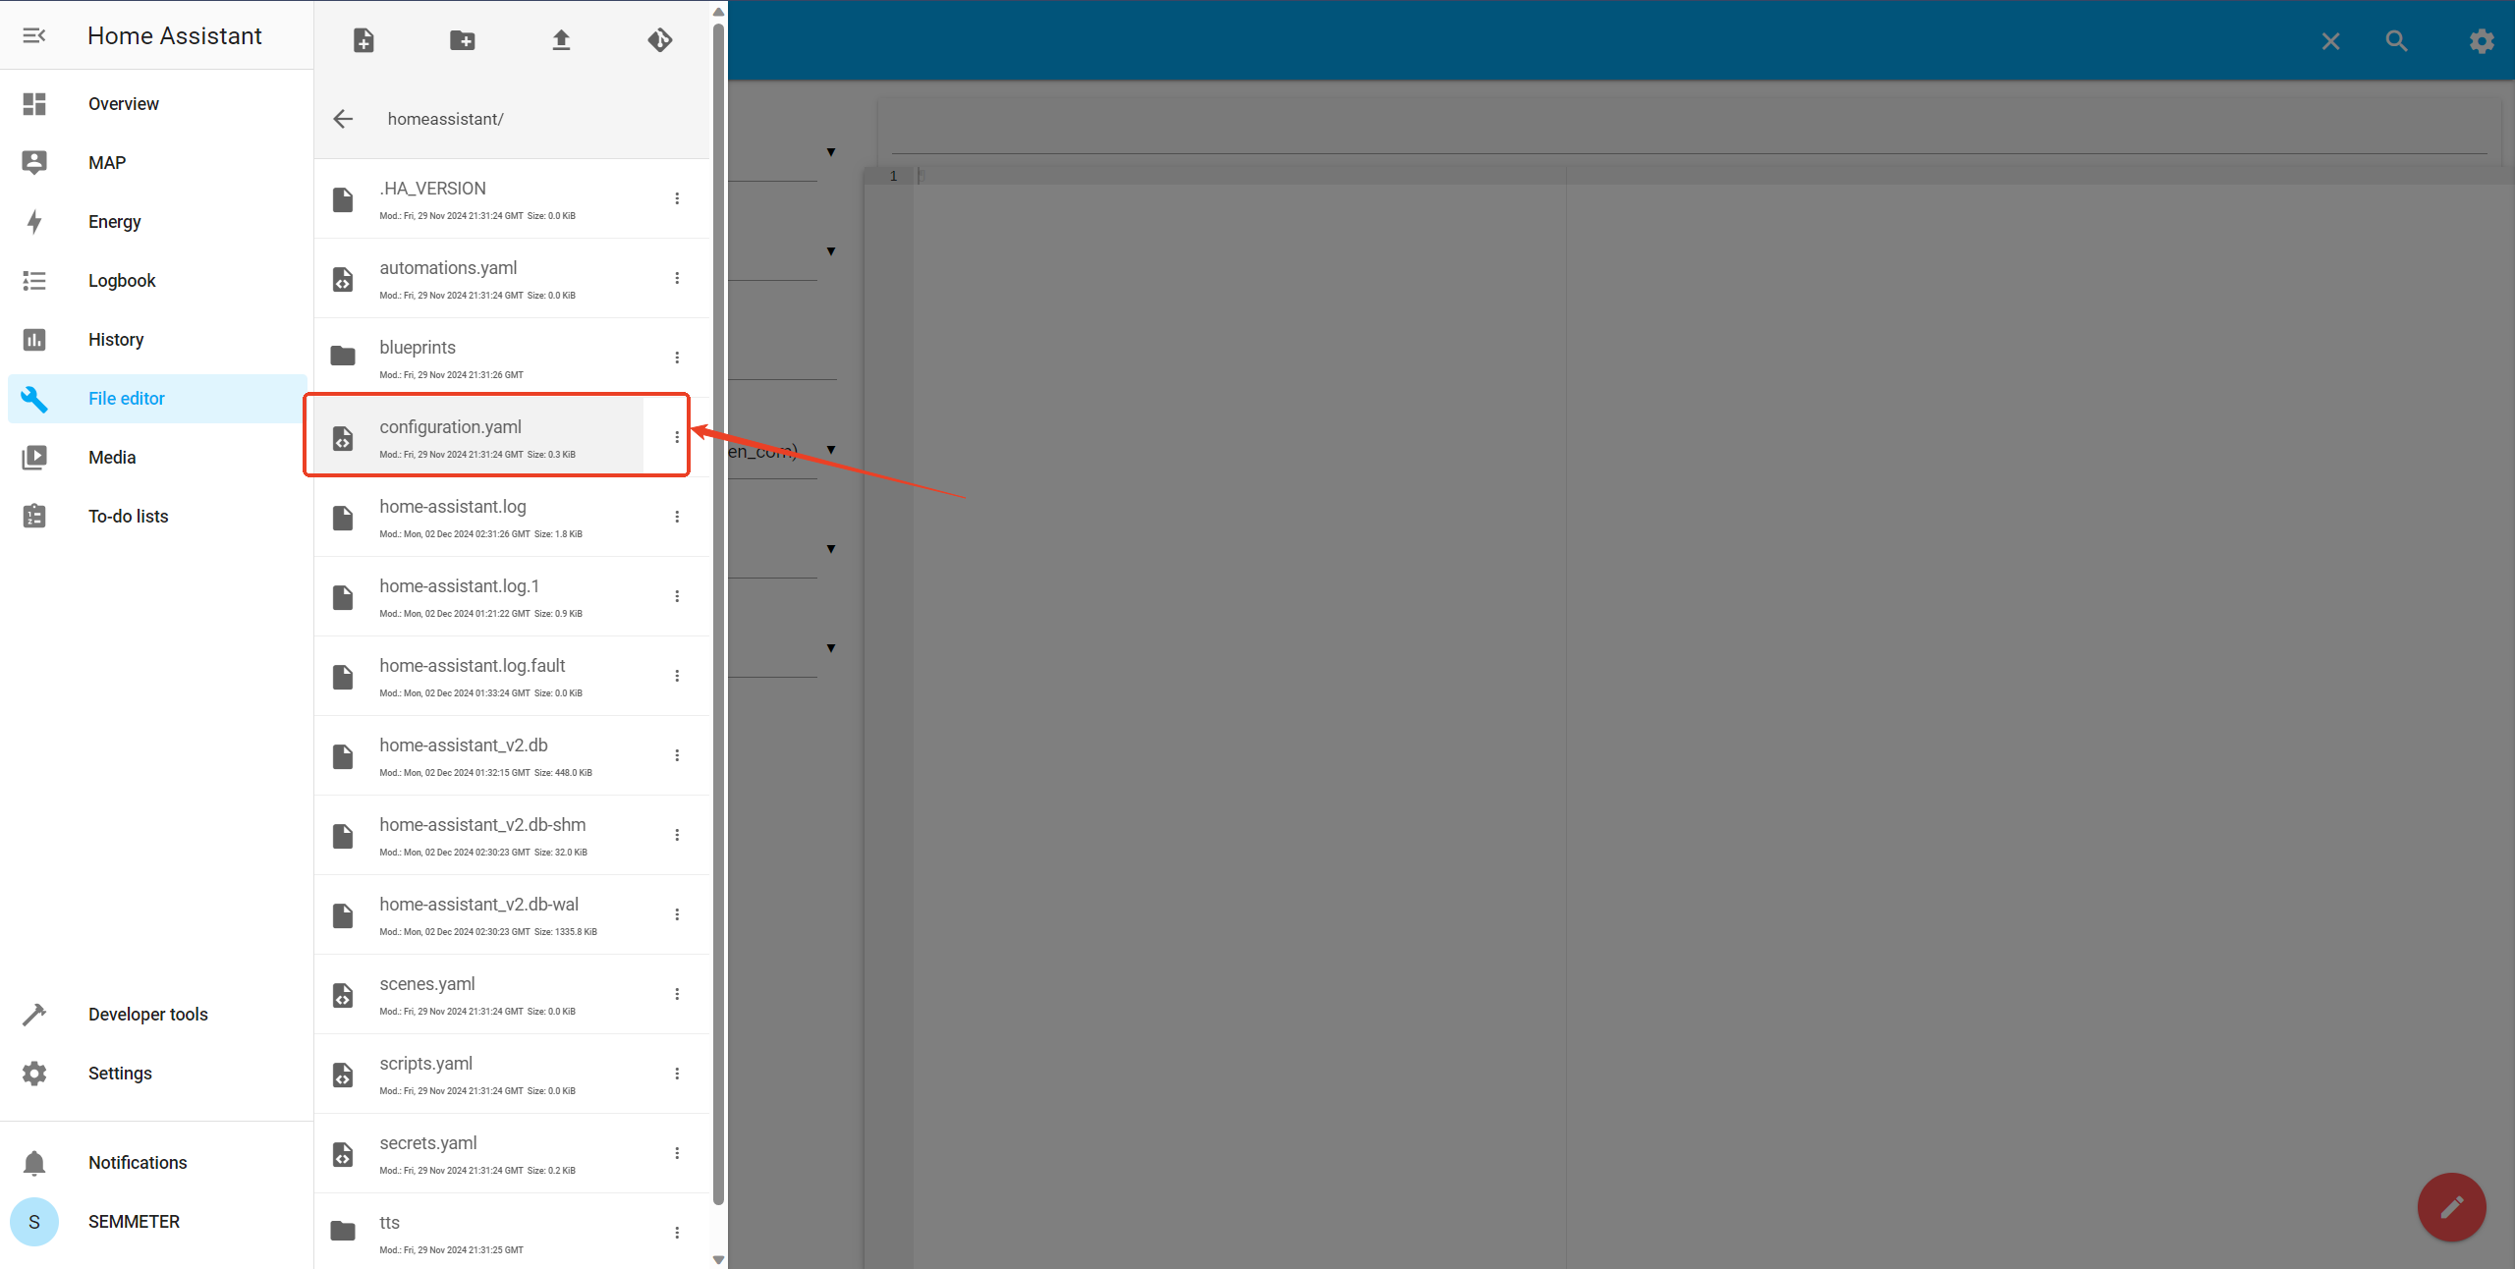

Copy the configuration code to configure.yaml and replace all the MAC addresses (the user's MAC address will be shown during the network configuration).

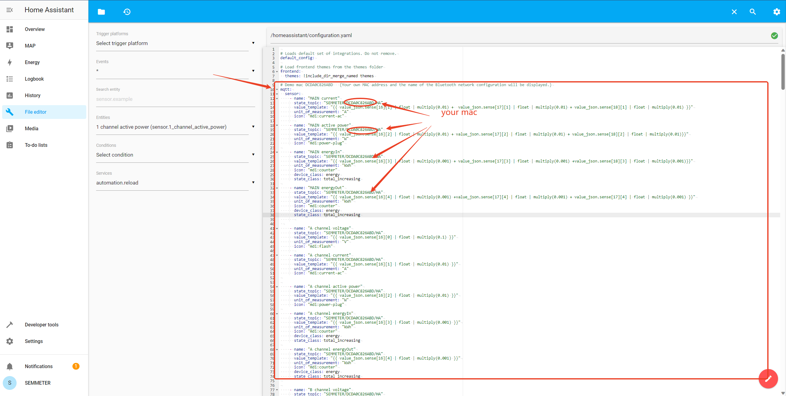

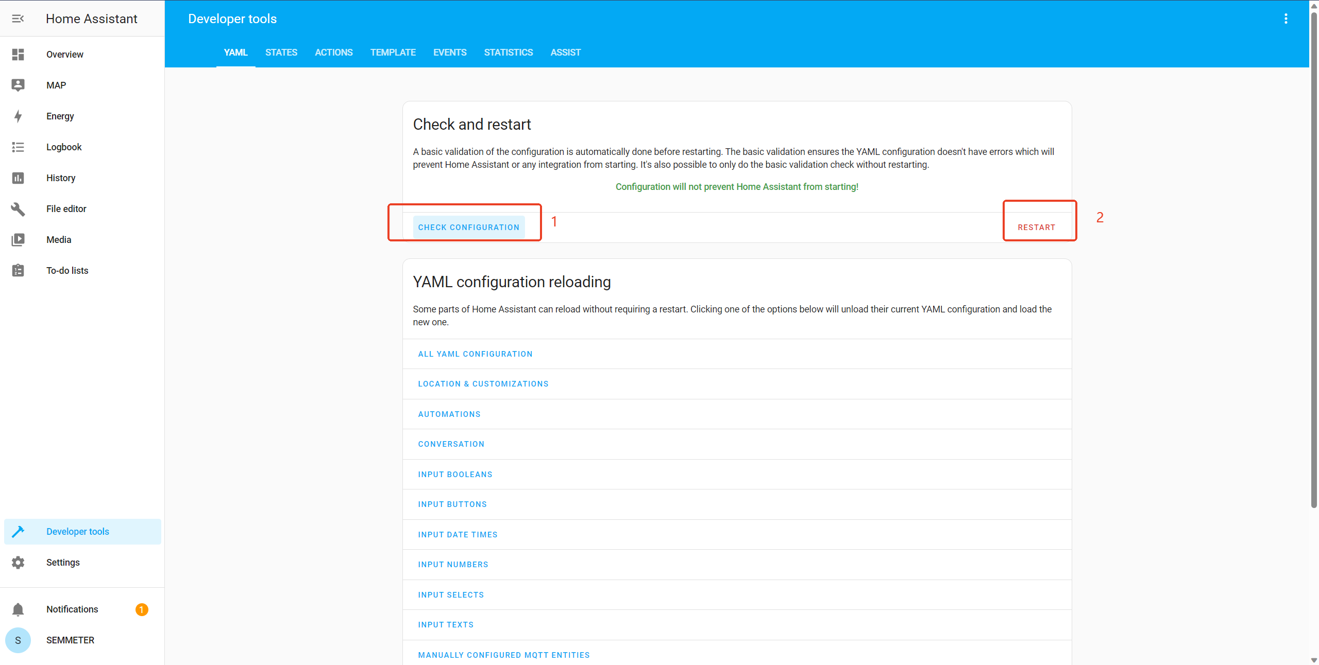

**Display semmeter data (Developer tools -> states)**

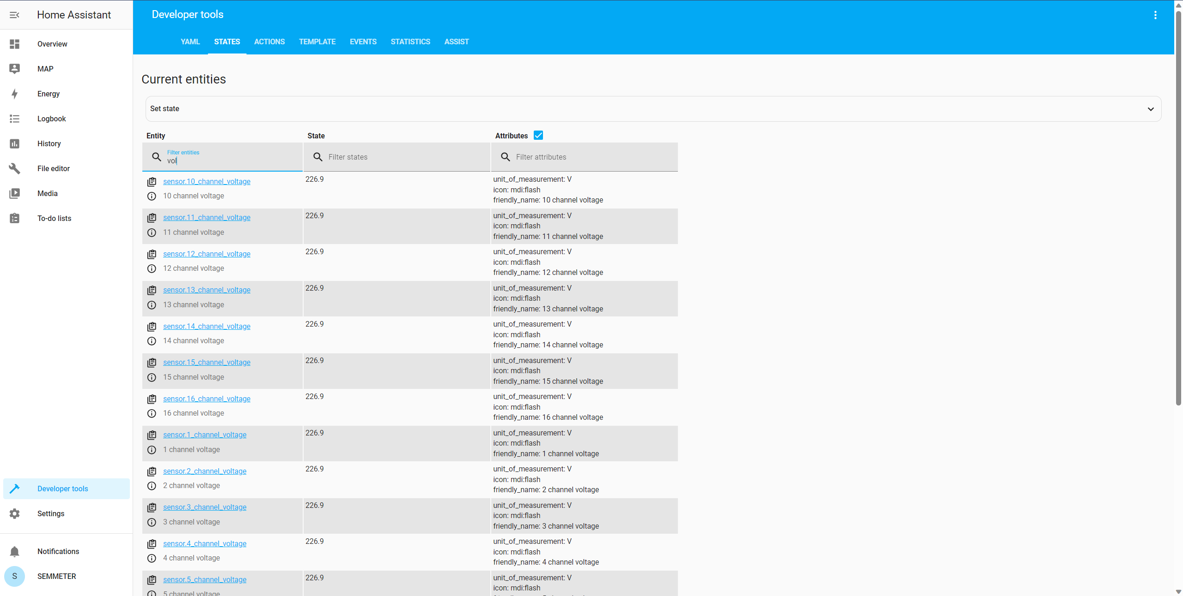

**Add CARD**

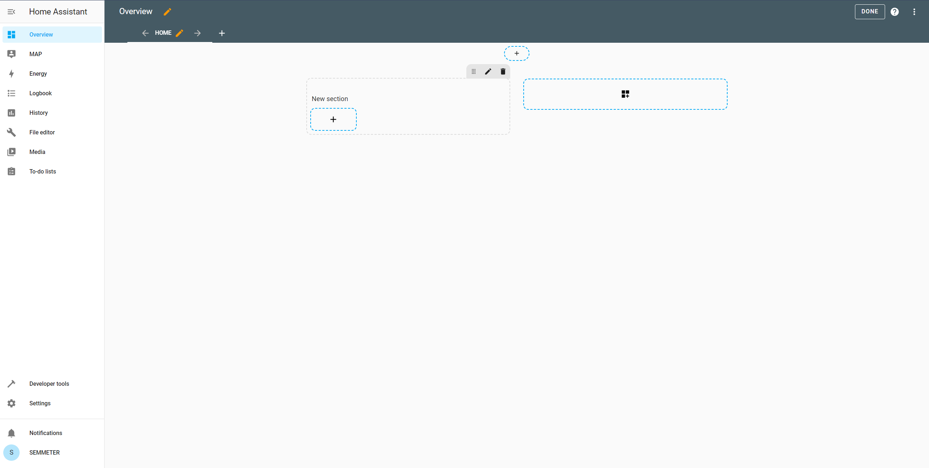

**Connect to your own MQTT server.**  
1：Set the IP address, port, account number and password of your MQTT server for the SEMMETER device.

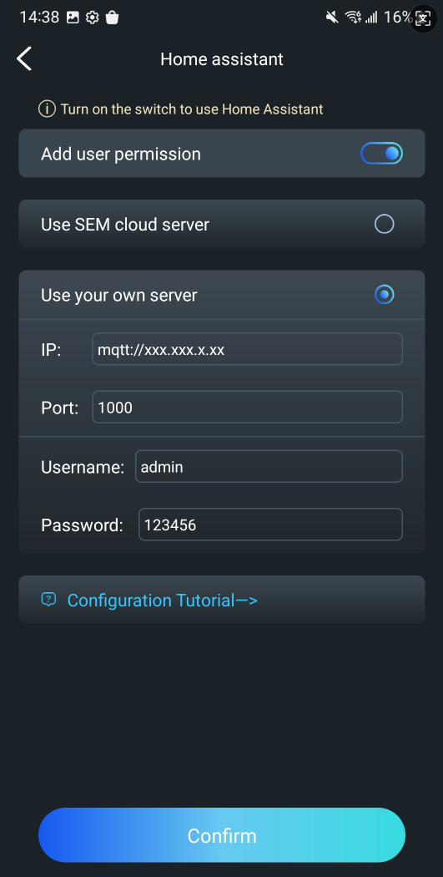

2：Configure your Home Assistant to connect to your server.

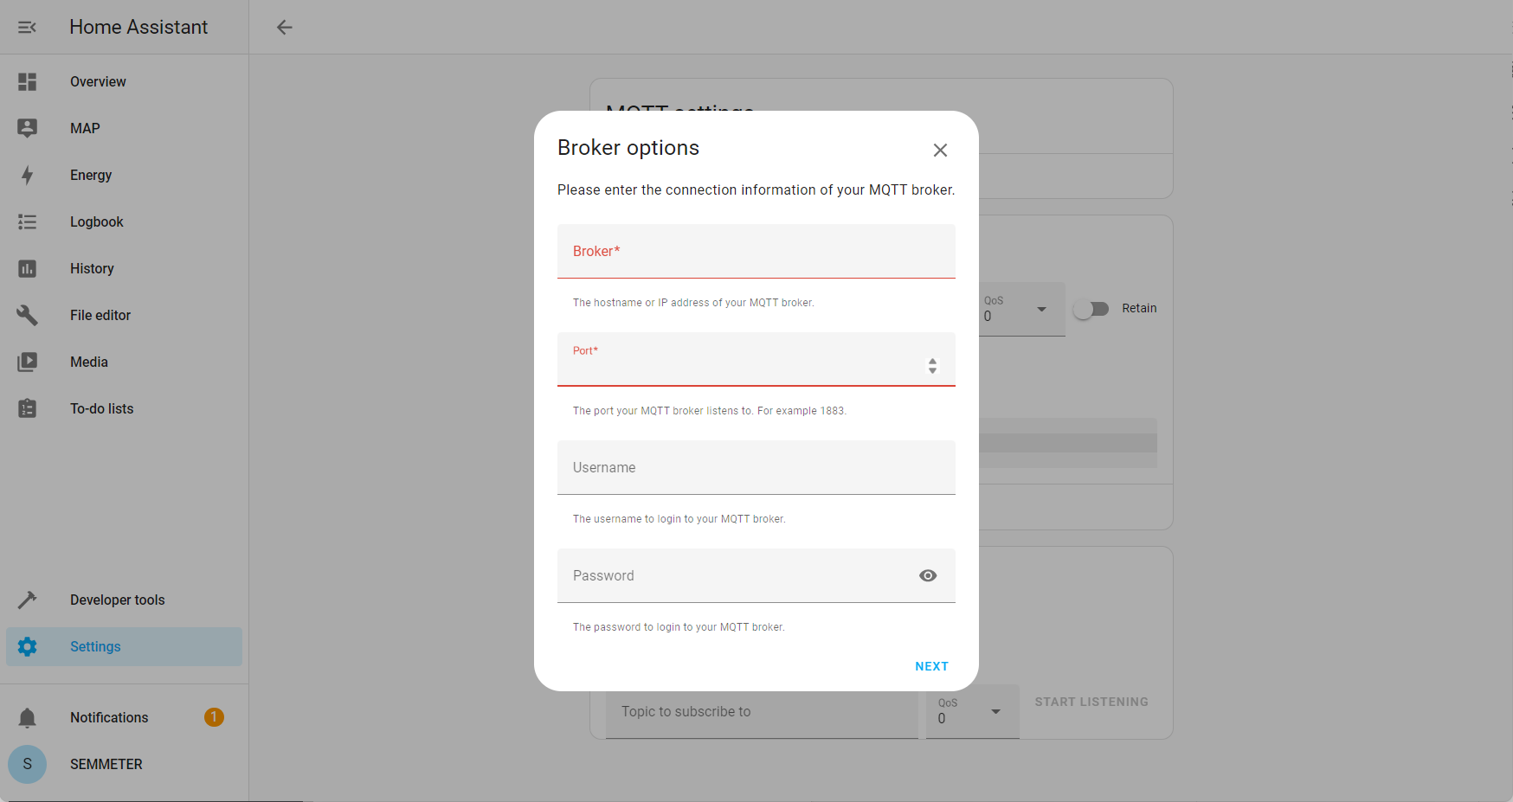

**configuration.yaml mqtt demo code:**

# Demo mac DCDA0C826ABD {Your own MAC address and the name of the Bluetooth network configuration will be displayed.}

mqtt:

sensor:

- name: "MAIN current"

state_topic: "SEMMETER/DCDA0C826ABD/HA"

value_template: "{{ value_json.sense[16][1] | float | multiply(0.01) + value_json.sense[17][1] | float | multiply(0.01) + value_json.sense[18][1] | float | multiply(0.01) }}"

unit_of_measurement: "A"

icon: "mdi:current-ac"

- name: "MAIN active power"

state_topic: "SEMMETER/DCDA0C826ABD/HA"

value_template: "{{ value_json.sense[16][2] | float | multiply(0.01) + value_json.sense[17][2] | float | multiply(0.01) + value_json.sense[18][2] | float | multiply(0.01)}}"

unit_of_measurement: "W"

icon: "mdi:power-plug"

- name: "MAIN energyIn"

state_topic: "SEMMETER/DCDA0C826ABD/HA"

value_template: "{{ value_json.sense[16][3] | float | multiply(0.001) + value_json.sense[17][3] | float | multiply(0.001) +value_json.sense[18][3] | float | multiply(0.001)}}"

unit_of_measurement: "kWh"

icon: "mdi:counter"

device_class: energy

state_class: total_increasing

- name: "MAIN energyOut"

state_topic: "SEMMETER/DCDA0C826ABD/HA"

value_template: "{{ value_json.sense[16][4] | float | multiply(0.001) +value_json.sense[17][4] | float | multiply(0.001) + value_json.sense[17][4] | float | multiply(0.001) }}"

unit_of_measurement: "kWh"

icon: "mdi:counter"

device_class: energy

state_class: total_increasing

- name: "A channel voltage"

state_topic: "SEMMETER/DCDA0C826ABD/HA"

value_template: "{{ value_json.sense[16][0] | float | multiply(0.1) }}"

unit_of_measurement: "V"

icon: "mdi:flash"

- name: "A channel current"

state_topic: "SEMMETER/DCDA0C826ABD/HA"

value_template: "{{ value_json.sense[16][1] | float | multiply(0.01) }}"

unit_of_measurement: "A"

icon: "mdi:current-ac"

- name: "A channel active power"

state_topic: "SEMMETER/DCDA0C826ABD/HA"

value_template: "{{ value_json.sense[16][2] | float | multiply(0.01) }}"

unit_of_measurement: "W"

icon: "mdi:power-plug"

- name: "A channel energyIn"

state_topic: "SEMMETER/DCDA0C826ABD/HA"

value_template: "{{ value_json.sense[16][3] | float | multiply(0.001) }}"

unit_of_measurement: "kWh"

icon: "mdi:counter"

device_class: energy

state_class: total_increasing

- name: "A channel energyOut"

state_topic: "SEMMETER/DCDA0C826ABD/HA"

value_template: "{{ value_json.sense[16][4] | float | multiply(0.001) }}"

unit_of_measurement: "kWh"

icon: "mdi:counter"

device_class: energy

state_class: total_increasing

- name: "B channel voltage"

state_topic: "SEMMETER/DCDA0C826ABD/HA"

value_template: "{{ value_json.sense[17][0] | float | multiply(0.1) }}"

unit_of_measurement: "V"

icon: "mdi:flash"

- name: "B channel current"

state_topic: "SEMMETER/DCDA0C826ABD/HA"

value_template: "{{ value_json.sense[17][1] | float | multiply(0.01) }}"

unit_of_measurement: "A"

icon: "mdi:current-ac"

- name: "B channel active power"

state_topic: "SEMMETER/DCDA0C826ABD/HA"

value_template: "{{ value_json.sense[17][2] | float | multiply(0.01) }}"

unit_of_measurement: "W"

icon: "mdi:power-plug"

- name: "B channel energyIn"

state_topic: "SEMMETER/DCDA0C826ABD/HA"

value_template: "{{ value_json.sense[17][3] | float | multiply(0.001) }}"

unit_of_measurement: "kWh"

icon: "mdi:counter"

device_class: energy

state_class: total_increasing

- name: "B channel energyOut"

state_topic: "SEMMETER/DCDA0C826ABD/HA"

value_template: "{{ value_json.sense[17][4] | float | multiply(0.001) }}"

unit_of_measurement: "kWh"

icon: "mdi:counter"

device_class: energy

state_class: total_increasing

- name: "C channel voltage"

state_topic: "SEMMETER/DCDA0C826ABD/HA"

value_template: "{{ value_json.sense[18][0] | float | multiply(0.1) }}"

unit_of_measurement: "V"

icon: "mdi:flash"

- name: "C channel current"

state_topic: "SEMMETER/DCDA0C826ABD/HA"

value_template: "{{ value_json.sense[18][1] | float | multiply(0.01) }}"

unit_of_measurement: "A"

icon: "mdi:current-ac"

- name: "C channel active power"

state_topic: "SEMMETER/DCDA0C826ABD/HA"

value_template: "{{ value_json.sense[18][2] | float | multiply(0.01) }}"

unit_of_measurement: "W"

icon: "mdi:power-plug"

- name: "C channel energyIn"

state_topic: "SEMMETER/DCDA0C826ABD/HA"

value_template: "{{ value_json.sense[18][3] | float | multiply(0.001) }}"

unit_of_measurement: "kWh"

icon: "mdi:counter"

device_class: energy

state_class: total_increasing

- name: "C channel energyOut"

state_topic: "SEMMETER/DCDA0C826ABD/HA"

value_template: "{{ value_json.sense[18][4] | float | multiply(0.001) }}"

unit_of_measurement: "kWh"

icon: "mdi:counter"

device_class: energy

state_class: total_increasing

- name: "1 channel voltage"

state_topic: "SEMMETER/DCDA0C826ABD/HA"

value_template: "{{ value_json.sense[0][0] | float | multiply(0.1) }}"

unit_of_measurement: "V"

icon: "mdi:flash"

- name: "1 channel current"

state_topic: "SEMMETER/DCDA0C826ABD/HA"

value_template: "{{ value_json.sense[0][1] | float | multiply(0.01) }}"

unit_of_measurement: "A"

icon: "mdi:current-ac"

- name: "1 channel active power"

state_topic: "SEMMETER/DCDA0C826ABD/HA"

value_template: "{{ value_json.sense[0][2] | float | multiply(0.01) }}"

unit_of_measurement: "W"

icon: "mdi:power-plug"

- name: "1 channel energyIn"

state_topic: "SEMMETER/DCDA0C826ABD/HA"

value_template: "{{ value_json.sense[0][3] | float | multiply(0.001) }}"

unit_of_measurement: "kWh"

icon: "mdi:counter"

device_class: energy

state_class: total_increasing

- name: "1 channel energyOut"

state_topic: "SEMMETER/DCDA0C826ABD/HA"

value_template: "{{ value_json.sense[0][4] | float | multiply(0.001) }}"

unit_of_measurement: "kWh"

icon: "mdi:counter"

device_class: energy

state_class: total_increasing

- name: "2 channel voltage"

state_topic: "SEMMETER/DCDA0C826ABD/HA"

value_template: "{{ value_json.sense[1][0] | float | multiply(0.1) }}"

unit_of_measurement: "V"

icon: "mdi:flash"

- name: "2 channel current"

state_topic: "SEMMETER/DCDA0C826ABD/HA"

value_template: "{{ value_json.sense[1][1] | float | multiply(0.01) }}"

unit_of_measurement: "A"

icon: "mdi:current-ac"

- name: "2 channel active power"

state_topic: "SEMMETER/DCDA0C826ABD/HA"

value_template: "{{ value_json.sense[1][2] | float | multiply(0.01) }}"

unit_of_measurement: "W"

icon: "mdi:power-plug"

- name: "2 channel energyIn"

state_topic: "SEMMETER/DCDA0C826ABD/HA"

value_template: "{{ value_json.sense[1][3] | float | multiply(0.001) }}"

unit_of_measurement: "kWh"

icon: "mdi:counter"

device_class: energy

state_class: total_increasing

- name: "2 channel energyOut"

state_topic: "SEMMETER/DCDA0C826ABD/HA"

value_template: "{{ value_json.sense[1][4] | float | multiply(0.001) }}"

unit_of_measurement: "kWh"

icon: "mdi:counter"

device_class: energy

state_class: total_increasing

- name: "3 channel voltage"

state_topic: "SEMMETER/DCDA0C826ABD/HA"

value_template: "{{ value_json.sense[2][0] | float | multiply(0.1) }}"

unit_of_measurement: "V"

icon: "mdi:flash"

- name: "3 channel current"

state_topic: "SEMMETER/DCDA0C826ABD/HA"

value_template: "{{ value_json.sense[2][1] | float | multiply(0.01) }}"

unit_of_measurement: "A"

icon: "mdi:current-ac"

- name: "3 channel active power"

state_topic: "SEMMETER/DCDA0C826ABD/HA"

value_template: "{{ value_json.sense[2][2] | float | multiply(0.01) }}"

unit_of_measurement: "W"

icon: "mdi:power-plug"

- name: "3 channel energyIn"

state_topic: "SEMMETER/DCDA0C826ABD/HA"

value_template: "{{ value_json.sense[2][3] | float | multiply(0.001) }}"

unit_of_measurement: "kWh"

icon: "mdi:counter"

device_class: energy

state_class: total_increasing

- name: "3 channel energyOut"

state_topic: "SEMMETER/DCDA0C826ABD/HA"

value_template: "{{ value_json.sense[2][4] | float | multiply(0.001) }}"

unit_of_measurement: "kWh"

icon: "mdi:counter"

device_class: energy

state_class: total_increasing

- name: "4 channel voltage"

state_topic: "SEMMETER/DCDA0C826ABD/HA"

value_template: "{{ value_json.sense[3][0] | float | multiply(0.1) }}"

unit_of_measurement: "V"

icon: "mdi:flash"

- name: "4 channel current"

state_topic: "SEMMETER/DCDA0C826ABD/HA"

value_template: "{{ value_json.sense[3][1] | float | multiply(0.01) }}"

unit_of_measurement: "A"

icon: "mdi:current-ac"

- name: "4 channel active power"

state_topic: "SEMMETER/DCDA0C826ABD/HA"

value_template: "{{ value_json.sense[3][2] | float | multiply(0.01) }}"

unit_of_measurement: "W"

icon: "mdi:power-plug"

- name: "4 channel energyIn"

state_topic: "SEMMETER/DCDA0C826ABD/HA"

value_template: "{{ value_json.sense[3][3] | float | multiply(0.001) }}"

unit_of_measurement: "kWh"

icon: "mdi:counter"

device_class: energy

state_class: total_increasing

- name: "4 channel energyOut"

state_topic: "SEMMETER/DCDA0C826ABD/HA"

value_template: "{{ value_json.sense[3][4] | float | multiply(0.001) }}"

unit_of_measurement: "kWh"

icon: "mdi:counter"

device_class: energy

state_class: total_increasing

- name: "5 channel voltage"

state_topic: "SEMMETER/DCDA0C826ABD/HA"

value_template: "{{ value_json.sense[4][0] | float | multiply(0.1) }}"

unit_of_measurement: "V"

icon: "mdi:flash"

- name: "5 channel current"

state_topic: "SEMMETER/DCDA0C826ABD/HA"

value_template: "{{ value_json.sense[4][1] | float | multiply(0.01) }}"

unit_of_measurement: "A"

icon: "mdi:current-ac"

- name: "5 channel active power"

state_topic: "SEMMETER/DCDA0C826ABD/HA"

value_template: "{{ value_json.sense[4][2] | float | multiply(0.01) }}"

unit_of_measurement: "W"

icon: "mdi:power-plug"

- name: "5 channel energyIn"

state_topic: "SEMMETER/DCDA0C826ABD/HA"

value_template: "{{ value_json.sense[4][3] | float | multiply(0.001) }}"

unit_of_measurement: "kWh"

icon: "mdi:counter"

device_class: energy

state_class: total_increasing

- name: "5 channel energyOut"

state_topic: "SEMMETER/DCDA0C826ABD/HA"

value_template: "{{ value_json.sense[4][4] | float | multiply(0.001) }}"

unit_of_measurement: "kWh"

icon: "mdi:counter"

device_class: energy

state_class: total_increasing

- name: "6 channel voltage"

state_topic: "SEMMETER/DCDA0C826ABD/HA"

value_template: "{{ value_json.sense[5][0] | float | multiply(0.1) }}"

unit_of_measurement: "V"

icon: "mdi:flash"

- name: "6 channel current"

state_topic: "SEMMETER/DCDA0C826ABD/HA"

value_template: "{{ value_json.sense[5][1] | float | multiply(0.01) }}"

unit_of_measurement: "A"

icon: "mdi:current-ac"

- name: "6 channel active power"

state_topic: "SEMMETER/DCDA0C826ABD/HA"

value_template: "{{ value_json.sense[5][2] | float | multiply(0.01) }}"

unit_of_measurement: "W"

icon: "mdi:power-plug"

- name: "6 channel energyIn"

state_topic: "SEMMETER/DCDA0C826ABD/HA"

value_template: "{{ value_json.sense[5][3] | float | multiply(0.001) }}"

unit_of_measurement: "kWh"

icon: "mdi:counter"

device_class: energy

state_class: total_increasing

- name: "6 channel energyOut"

state_topic: "SEMMETER/DCDA0C826ABD/HA"

value_template: "{{ value_json.sense[5][4] | float | multiply(0.001) }}"

unit_of_measurement: "kWh"

icon: "mdi:counter"

device_class: energy

state_class: total_increasing

- name: "7 channel voltage"

state_topic: "SEMMETER/DCDA0C826ABD/HA"

value_template: "{{ value_json.sense[6][0] | float | multiply(0.1) }}"

unit_of_measurement: "V"

icon: "mdi:flash"

- name: "7 channel current"

state_topic: "SEMMETER/DCDA0C826ABD/HA"

value_template: "{{ value_json.sense[6][1] | float | multiply(0.01) }}"

unit_of_measurement: "A"

icon: "mdi:current-ac"

- name: "7 channel active power"

state_topic: "SEMMETER/DCDA0C826ABD/HA"

value_template: "{{ value_json.sense[6][2] | float | multiply(0.01) }}"

unit_of_measurement: "W"

icon: "mdi:power-plug"

- name: "7 channel energyIn"

state_topic: "SEMMETER/DCDA0C826ABD/HA"

value_template: "{{ value_json.sense[6][3] | float | multiply(0.001) }}"

unit_of_measurement: "kWh"

icon: "mdi:counter"

device_class: energy

state_class: total_increasing

- name: "7 channel energyOut"

state_topic: "SEMMETER/DCDA0C826ABD/HA"

value_template: "{{ value_json.sense[6][4] | float | multiply(0.001) }}"

unit_of_measurement: "kWh"

icon: "mdi:counter"

device_class: energy

state_class: total_increasing

- name: "8 channel voltage"

state_topic: "SEMMETER/DCDA0C826ABD/HA"

value_template: "{{ value_json.sense[7][0] | float | multiply(0.1) }}"

unit_of_measurement: "V"

icon: "mdi:flash"

- name: "8 channel current"

state_topic: "SEMMETER/DCDA0C826ABD/HA"

value_template: "{{ value_json.sense[7][1] | float | multiply(0.01) }}"

unit_of_measurement: "A"

icon: "mdi:current-ac"

- name: "8 channel active power"

state_topic: "SEMMETER/DCDA0C826ABD/HA"

value_template: "{{ value_json.sense[7][2] | float | multiply(0.01) }}"

unit_of_measurement: "W"

icon: "mdi:power-plug"

- name: "8 channel energyIn"

state_topic: "SEMMETER/DCDA0C826ABD/HA"

value_template: "{{ value_json.sense[7][3] | float | multiply(0.001) }}"

unit_of_measurement: "kWh"

icon: "mdi:counter"

device_class: energy

state_class: total_increasing

- name: "8 channel energyOut"

state_topic: "SEMMETER/DCDA0C826ABD/HA"

value_template: "{{ value_json.sense[7][4] | float | multiply(0.001) }}"

unit_of_measurement: "kWh"

icon: "mdi:counter"

device_class: energy

state_class: total_increasing

- name: "9 channel voltage"

state_topic: "SEMMETER/DCDA0C826ABD/HA"

value_template: "{{ value_json.sense[8][0] | float | multiply(0.1) }}"

unit_of_measurement: "V"

icon: "mdi:flash"

- name: "9 channel current"

state_topic: "SEMMETER/DCDA0C826ABD/HA"

value_template: "{{ value_json.sense[8][1] | float | multiply(0.01) }}"

unit_of_measurement: "A"

icon: "mdi:current-ac"

- name: "9 channel active power"

state_topic: "SEMMETER/DCDA0C826ABD/HA"

value_template: "{{ value_json.sense[8][2] | float | multiply(0.01) }}"

unit_of_measurement: "W"

icon: "mdi:power-plug"

- name: "9 channel energyIn"

state_topic: "SEMMETER/DCDA0C826ABD/HA"

value_template: "{{ value_json.sense[8][3] | float | multiply(0.001) }}"

unit_of_measurement: "kWh"

icon: "mdi:counter"

device_class: energy

state_class: total_increasing

- name: "9 channel energyOut"

state_topic: "SEMMETER/DCDA0C826ABD/HA"

value_template: "{{ value_json.sense[8][4] | float | multiply(0.001) }}"

unit_of_measurement: "kWh"

icon: "mdi:counter"

device_class: energy

state_class: total_increasing

- name: "10 channel voltage"

state_topic: "SEMMETER/DCDA0C826ABD/HA"

value_template: "{{ value_json.sense[9][0] | float | multiply(0.1) }}"

unit_of_measurement: "V"

icon: "mdi:flash"

- name: "10 channel current"

state_topic: "SEMMETER/DCDA0C826ABD/HA"

value_template: "{{ value_json.sense[9][1] | float | multiply(0.01) }}"

unit_of_measurement: "A"

icon: "mdi:current-ac"

- name: "10 channel active power"

state_topic: "SEMMETER/DCDA0C826ABD/HA"

value_template: "{{ value_json.sense[9][2] | float | multiply(0.01) }}"

unit_of_measurement: "W"

icon: "mdi:power-plug"

- name: "10 channel energyIn"

state_topic: "SEMMETER/DCDA0C826ABD/HA"

value_template: "{{ value_json.sense[9][3] | float | multiply(0.001) }}"

unit_of_measurement: "kWh"

icon: "mdi:counter"

device_class: energy

state_class: total_increasing

- name: "10 channel energyOut"

state_topic: "SEMMETER/DCDA0C826ABD/HA"

value_template: "{{ value_json.sense[9][4] | float | multiply(0.001) }}"

unit_of_measurement: "kWh"

icon: "mdi:counter"

device_class: energy

state_class: total_increasing

- name: "11 channel voltage"

state_topic: "SEMMETER/DCDA0C826ABD/HA"

value_template: "{{ value_json.sense[10][0] | float | multiply(0.1) }}"

unit_of_measurement: "V"

icon: "mdi:flash"

- name: "11 channel current"

state_topic: "SEMMETER/DCDA0C826ABD/HA"

value_template: "{{ value_json.sense[10][1] | float | multiply(0.01) }}"

unit_of_measurement: "A"

icon: "mdi:current-ac"

- name: "11 channel active power"

state_topic: "SEMMETER/DCDA0C826ABD/HA"

value_template: "{{ value_json.sense[10][2] | float | multiply(0.01) }}"

unit_of_measurement: "W"

icon: "mdi:power-plug"

- name: "11 channel energyIn"

state_topic: "SEMMETER/DCDA0C826ABD/HA"

value_template: "{{ value_json.sense[10][3] | float | multiply(0.001) }}"

unit_of_measurement: "kWh"

icon: "mdi:counter"

device_class: energy

state_class: total_increasing

- name: "11 channel energyOut"

state_topic: "SEMMETER/DCDA0C826ABD/HA"

value_template: "{{ value_json.sense[10][4] | float | multiply(0.001) }}"

unit_of_measurement: "kWh"

icon: "mdi:counter"

device_class: energy

state_class: total_increasing

- name: "12 channel voltage"

state_topic: "SEMMETER/DCDA0C826ABD/HA"

value_template: "{{ value_json.sense[11][0] | float | multiply(0.1) }}"

unit_of_measurement: "V"

icon: "mdi:flash"

- name: "12 channel current"

state_topic: "SEMMETER/DCDA0C826ABD/HA"

value_template: "{{ value_json.sense[11][1] | float | multiply(0.01) }}"

unit_of_measurement: "A"

icon: "mdi:current-ac"

- name: "12 channel active power"

state_topic: "SEMMETER/DCDA0C826ABD/HA"

value_template: "{{ value_json.sense[11][2] | float | multiply(0.01) }}"

unit_of_measurement: "W"

icon: "mdi:power-plug"

- name: "12 channel energyIn"

state_topic: "SEMMETER/DCDA0C826ABD/HA"

value_template: "{{ value_json.sense[11][3] | float | multiply(0.001) }}"

unit_of_measurement: "kWh"

icon: "mdi:counter"

device_class: energy

state_class: total_increasing

- name: "12 channel energyOut"

state_topic: "SEMMETER/DCDA0C826ABD/HA"

value_template: "{{ value_json.sense[11][4] | float | multiply(0.001) }}"

unit_of_measurement: "kWh"

icon: "mdi:counter"

device_class: energy

state_class: total_increasing

- name: "13 channel voltage"

state_topic: "SEMMETER/DCDA0C826ABD/HA"

value_template: "{{ value_json.sense[12][0] | float | multiply(0.1) }}"

unit_of_measurement: "V"

icon: "mdi:flash"

- name: "13 channel current"

state_topic: "SEMMETER/DCDA0C826ABD/HA"

value_template: "{{ value_json.sense[12][1] | float | multiply(0.01) }}"

unit_of_measurement: "A"

icon: "mdi:current-ac"

- name: "13 channel active power"

state_topic: "SEMMETER/DCDA0C826ABD/HA"

value_template: "{{ value_json.sense[12][2] | float | multiply(0.01) }}"

unit_of_measurement: "W"

icon: "mdi:power-plug"

- name: "13 channel energyIn"

state_topic: "SEMMETER/DCDA0C826ABD/HA"

value_template: "{{ value_json.sense[12][3] | float | multiply(0.001) }}"

unit_of_measurement: "kWh"

icon: "mdi:counter"

device_class: energy

state_class: total_increasing

- name: "13 channel energyOut"

state_topic: "SEMMETER/DCDA0C826ABD/HA"

value_template: "{{ value_json.sense[12][4] | float | multiply(0.001) }}"

unit_of_measurement: "kWh"

icon: "mdi:counter"

device_class: energy

state_class: total_increasing

- name: "14 channel voltage"

state_topic: "SEMMETER/DCDA0C826ABD/HA"

value_template: "{{ value_json.sense[13][0] | float | multiply(0.1) }}"

unit_of_measurement: "V"

icon: "mdi:flash"

- name: "14 channel current"

state_topic: "SEMMETER/DCDA0C826ABD/HA"

value_template: "{{ value_json.sense[13][1] | float | multiply(0.01) }}"

unit_of_measurement: "A"

icon: "mdi:current-ac"

- name: "14 channel active power"

state_topic: "SEMMETER/DCDA0C826ABD/HA"

value_template: "{{ value_json.sense[13][2] | float | multiply(0.01) }}"

unit_of_measurement: "W"

icon: "mdi:power-plug"

- name: "14 channel energyIn"

state_topic: "SEMMETER/DCDA0C826ABD/HA"

value_template: "{{ value_json.sense[13][3] | float | multiply(0.001) }}"

unit_of_measurement: "kWh"

icon: "mdi:counter"

device_class: energy

state_class: total_increasing

- name: "14 channel energyOut"

state_topic: "SEMMETER/DCDA0C826ABD/HA"

value_template: "{{ value_json.sense[13][4] | float | multiply(0.001) }}"

unit_of_measurement: "kWh"

icon: "mdi:counter"

device_class: energy

state_class: total_increasing

- name: "15 channel voltage"

state_topic: "SEMMETER/DCDA0C826ABD/HA"

value_template: "{{ value_json.sense[14][0] | float | multiply(0.1) }}"

unit_of_measurement: "V"

icon: "mdi:flash"

- name: "15 channel current"

state_topic: "SEMMETER/DCDA0C826ABD/HA"

value_template: "{{ value_json.sense[14][1] | float | multiply(0.01) }}"

unit_of_measurement: "A"

icon: "mdi:current-ac"

- name: "15 channel active power"

state_topic: "SEMMETER/DCDA0C826ABD/HA"

value_template: "{{ value_json.sense[14][2] | float | multiply(0.01) }}"

unit_of_measurement: "W"

icon: "mdi:power-plug"

- name: "15 channel energyIn"

state_topic: "SEMMETER/DCDA0C826ABD/HA"

value_template: "{{ value_json.sense[14][3] | float | multiply(0.001) }}"

unit_of_measurement: "kWh"

icon: "mdi:counter"

device_class: energy

state_class: total_increasing

- name: "15 channel energyOut"

state_topic: "SEMMETER/DCDA0C826ABD/HA"

value_template: "{{ value_json.sense[14][4] | float | multiply(0.001) }}"

unit_of_measurement: "kWh"

icon: "mdi:counter"

device_class: energy

state_class: total_increasing

- name: "16 channel voltage"

state_topic: "SEMMETER/DCDA0C826ABD/HA"

value_template: "{{ value_json.sense[15][0] | float | multiply(0.1) }}"

unit_of_measurement: "V"

icon: "mdi:flash"

- name: "16 channel current"

state_topic: "SEMMETER/DCDA0C826ABD/HA"

value_template: "{{ value_json.sense[15][1] | float | multiply(0.01) }}"

unit_of_measurement: "A"

icon: "mdi:current-ac"

- name: "16 channel active power"

state_topic: "SEMMETER/DCDA0C826ABD/HA"

value_template: "{{ value_json.sense[15][2] | float | multiply(0.01) }}"

unit_of_measurement: "W"

icon: "mdi:power-plug"

- name: "16 channel energyIn"

state_topic: "SEMMETER/DCDA0C826ABD/HA"

value_template: "{{ value_json.sense[15][3] | float | multiply(0.001) }}"

unit_of_measurement: "kWh"

icon: "mdi:counter"

device_class: energy

state_class: total_increasing

- name: "16 channel energyOut"

state_topic: "SEMMETER/DCDA0C826ABD/HA"

value_template: "{{ value_json.sense[15][4] | float | multiply(0.001) }}"

unit_of_measurement: "kWh"

icon: "mdi:counter"

device_class: energy

state_class: total_increasing